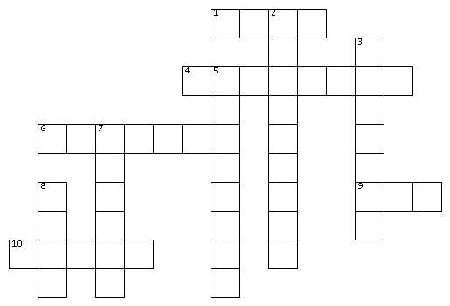

ACROSS  
1. Keyword used to define a Common Table Expression in SQL(4)  
4. The GCP service used for running Apache Hadoop and Apache Spark clusters to process large datasets(8)  
6. The AI-powered assistant developed by Microsoft that helps users write code, create content, and automate tasks across Microsoft 365 applications(7)  
9. Chart commonly used to represent categorical data(3)  
10. You have a table containing January data and have to combine that with February data having the same format. The SQL keyword that would be useful is __________ (5)  
  
DOWN  
2. The full form of T in ETL and ELT(9)  
3. The Microsoft tool used to create business intelligence reports and one of the most popular in the market(7)  
5. Microsoft platform used to automate workflows and processes across services and apps is called Power _______ (8)  
7. Programming language widely used for data analytics due to its extensive libraries like pandas and numpy(6)  
8. Most commonly used chart to show trends over time(4)

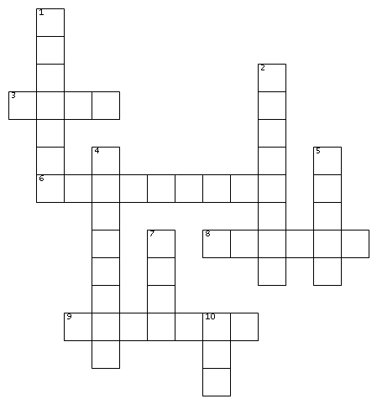

ACROSS  
3. Keyword used to define a Common Table Expression in SQL(4)  
6. The full form of T in ETL and ELT(9)  
8. Programming language widely used for data analytics due to its extensive libraries like pandas and numpy(6)  
9. The Microsoft tool used to create business intelligence reports and one of the most popular in the market(7)  
  
DOWN  
1. The AI-powered assistant developed by Microsoft that helps users write code, create content, and automate tasks across Microsoft 365 applications(7)  
2. Microsoft platform used to automate workflows and processes across services and apps is called Power _______ (8)  
4. The GCP service used for running Apache Hadoop and Apache Spark clusters to process large datasets(8)  
5. You have a table containing January data and have to combine that with February data having the same format. The SQL keyword that would be useful is __________ (5)  
7. Most commonly used chart to show trends over time(4)  
10. Chart commonly used to represent categorical data(3)

ACROSS  
1. Keyword used to define a Common Table Expression in SQL(4)  
4. The GCP service used for running Apache Hadoop and Apache Spark clusters to process large datasets(8)  
6. The AI-powered assistant developed by Microsoft that helps users write code, create content, and automate tasks across Microsoft 365 applications(7)  
9. Chart commonly used to represent categorical data(3)  
10. You have a table containing January data and have to combine that with February data having the same format. The SQL keyword that would be useful is __________ (5)  
  
DOWN  
2. The full form of T in ETL and ELT(9)  
3. The Microsoft tool used to create business intelligence reports and one of the most popular in the market(7)  
5. Microsoft platform used to automate workflows and processes across services and apps is called Power _______ (8)  
7. Programming language widely used for data analytics due to its extensive libraries like pandas and numpy(6)  
8. Most commonly used chart to show trends over time(4)



ACROSS  
3. Keyword used to define a Common Table Expression in SQL(4)  
6. The full form of T in ETL and ELT(9)  
8. Programming language widely used for data analytics due to its extensive libraries like pandas and numpy(6)  
9. The Microsoft tool used to create business intelligence reports and one of the most popular in the market(7)  
  
DOWN  
1. The AI-powered assistant developed by Microsoft that helps users write code, create content, and automate tasks across Microsoft 365 applications(7)  
2. Microsoft platform used to automate workflows and processes across services and apps is called Power _______ (8)  
4. The GCP service used for running Apache Hadoop and Apache Spark clusters to process large datasets(8)  
5. You have a table containing January data and have to combine that with February data having the same format. The SQL keyword that would be useful is __________ (5)  
7. Most commonly used chart to show trends over time(4)  
10. Chart commonly used to represent categorical data(3)

